Fully Automatic Glue-Free Rewinding Machine ZRF-1300
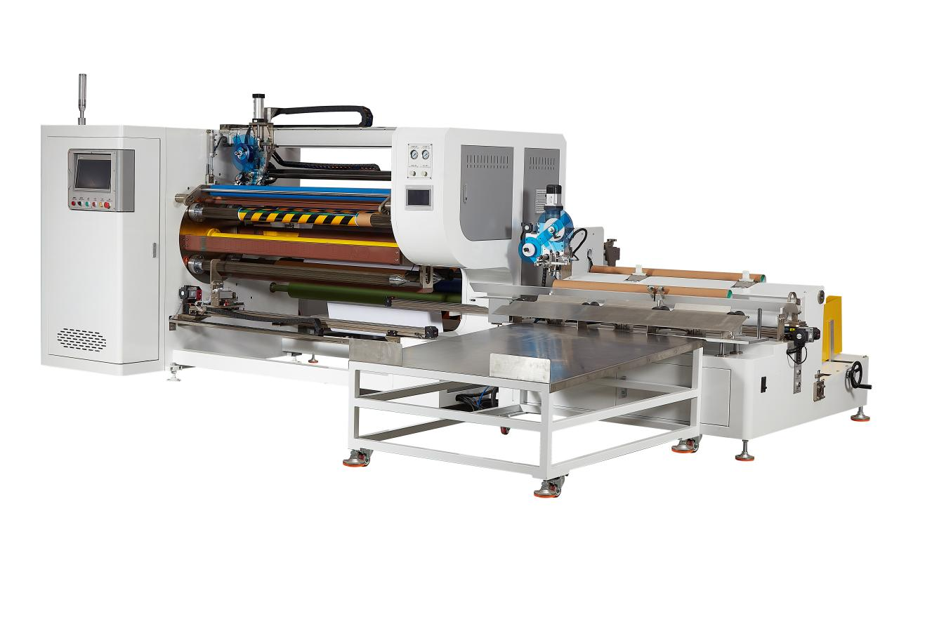
Equipment layout：
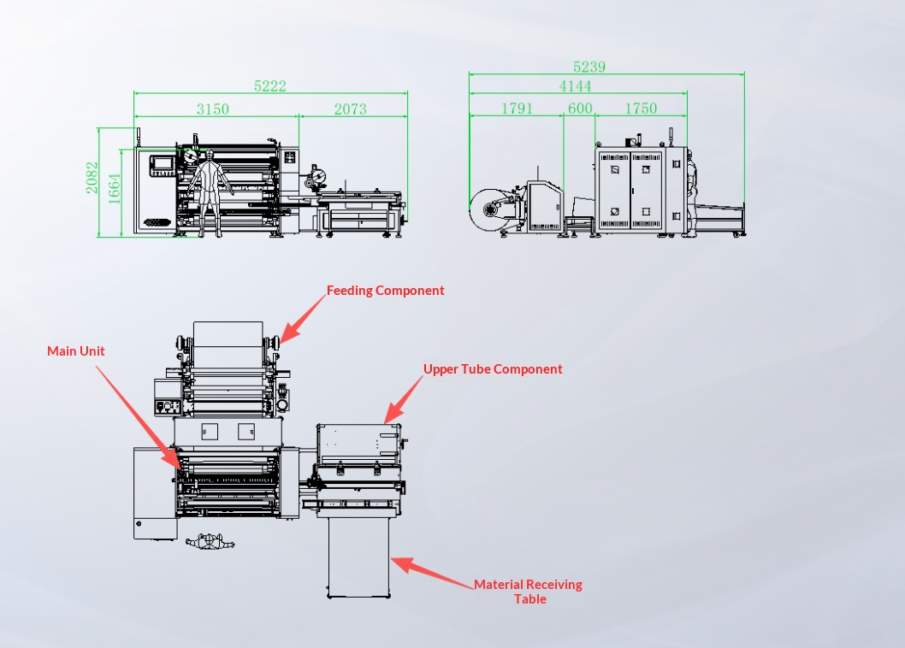
Basic Use：
Mainly used for glue-free rewinding of materials such as aluminum foil tape, copper foil tape, automotive paint protection film, advertising paper, color-changing film and kraft paper.
Product characteristics：
- Adopts PC-based motion control system; the whole machine is driven by 11 servo motors, eliminating the instability of pneumatic control and improving equipment stability and efficiency. (Servo-controlled winding, servo-controlled active traction, servo-controlled label pulling, servo-controlled adhesive application, servo-controlled reversing & shaft switching, servo-controlled discharging, servo-controlled winding pressure roller, servo-controlled cutting knife, servo-controlled finishing, servo-controlled finishing labeling, servo-controlled paper core feeding).
- Adopts a high-precision indexer drive positioning structure with 4-axis automatic switching, enabling non-stop production and improving production efficiency.
- Equipped with automatic labeling at winding and finishing sections, ensuring flat joints for easy subsequent processing.
- Automatic smoothing rollers installed at winding and finishing sections ensure fast sealing without material wrinkles.
- Adopts our self-developed zero-friction zero-contact rewinding structure, replacing traditional shaft-locking mechanism; the machine runs silently without material damage.
- Servo-driven automatic shifting pressure roller automatically follows material diameter changes, maintaining a consistent gap between pressure roller and winding shaft for flatter rewinding.
- Adopts hydraulic brake automatic loading to prevent master roll paper core deformation and shaft threading difficulty, ensuring convenient, fast and labor-saving operation.
- Equipped with automatic alarm and shutdown for material absence to reduce material waste.
- Built-in automatic deviation correction to avoid defective products caused by uneven master roll materials.
- Fitted with a material receiving platform for easy material threading, improved efficiency and reduced waste.
- Servo modules drive pulling/releasing of sealing labels; length and position are freely adjustable for convenient setup and high positioning accuracy.
- Mobile discharge table stores 20–40 finished rolls and can be moved freely for easy subsequent processing.
- Automatic paper core loading, servo-driven core threading, automatic adhesive application, automatic finishing & sealing labeling, automatic cutting and automatic discharging.
- Automatic tension control for winding/unwinding ensures stable tension, flat lamination and smooth start/stop. Edge correction guarantees flat rewinding.
- Servo-driven winding with digital linear tension increase (tension calculated per revolution) enables smooth transition of winding/unwinding force.
- Servo motor-driven feeding ensures accurate length calculation. Servo torque-controlled winding delivers stable, precise tension for high-quality rolls with flat end faces.
- Unwinding uses shaftless hydraulic brake for easy/fast loading/unloading; equipped with hydraulic cylinder lifting, automatic deviation correction and magnetic powder brake roll-diameter-based automatic tension control for precise torque regulation.
- Rotary cutting with tungsten steel circular knife + automatic knife cleaning system; durable blade with neat cuts.
- Alarms and shutdowns for material absence, material breakage and paper core shortage.
- Equipped with HCFA motion control system, supporting one-click start and easy specification changeover.
- Enables unmanned production; one operator can manage multiple machines, significantly reducing labor costs and improving efficiency.

Main Technical Parameters：
Model | SWF-1300
paper core | (Customizable & freely replaceable components）  76
Unwinding master roll | 800mm(MAX)
Rewinding diameter | 100-160mm
Rewind width | W（800-1300）mm
Production speed | 200m/min  4-5pcs/min（15m） subject to rewinding length
power supply | 380V 50/60HZ/15KW
air pressure | 5KG
Machine size | 5239*5222*2082mm
Net Weight | 3500KG

Configuration parameters：
model | SWF-1300
touch screen | 14-inch MCGS HMI
Rack wall board | 36mm
Motion controller | HCFA
Active traction servo motor | HCFA
Active traction servo driver | HCFA
Reversing Servo Motor | HCFA
Reversing Driver | HCFA
Adhesive Application Servo Motor | HCFA
Adhesive Application Driver | HCFA
Label Pulling Servo Motor | HCFA
Label Pulling Driver | HCFA
Labeling Servo Motor | HCFA
Labeling Driver | HCFA
Discharge servo motor | HCFA
Discharge driver | HCFA
Coiling press roller servo motor | HCFA
Winding press roll driver | HCFA
Traction Servo Motor | HCFA
Traction Driver | HCFA
Cutter servo motor | HCFA
Cutter driver | HCFA
Winding Servo Motor | HCFA
Winding Servo Drive | HCFA
Pipe threading servo motor | HCFA
Pipe threading servo driver | HCFA
Finishing Servo Motor | HCFA
Finishing Servo Driver | HCFA
Four-axis flip divider | JUJIU
Motor | MaiLi
Cutter motor | MaiLi
Reducer | SMETRE
Magnetic powder brake | WREZUN
Air switch | CHINT
Switching power supply | Mingwei China
Linear guide | KENIC
Deviation Correction System | Youdao
Photoelectric sensor | BOJKE
Material detection sensor | BOJKE
Proximity Switch | Yangming
Contactor | Schneider
Relay | IDEA
Button switch | Schneider
Tri-color warning light | TAYB
Solenoid valve | ASICKO
Cylinder | AIRTAC
Linear slide | HIWIN
Magnetic switch | AIRTAC
Unwinding, waste collection 3 inch gas expansion shaft | TAIWAN CHINA
bearing | NSK
Traction shaft | Nano coating for anti-sticking
Compression roll | Package of silica gel
transition roller | Hard Anodizing
scalpel | 110MM tungsten steel round knife

